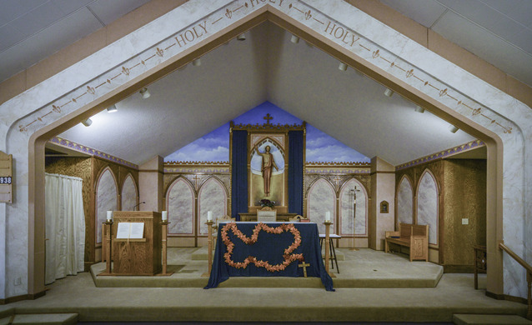
St. Mary’s Immaculate Conception
Parish Council
Hammond, Wisconsin
Meeting Date January 27, 2026

- The meeting was called to order at 7:00 pm by Rick Graf.
- Attendance 7.
- Attending: John Rukavina (phone), Todd Edelman, Bob Aune, Rick Graf, Janice Narlock, Dennis Malacek and Joe Shakal.
- No Minutes from the December meeting. Parish Renovation was discussed.

- Agenda:
  - Committee Updates:
  - 1. Finance – Todd Edelman
    - State of the Parish – letters went out with financial numbers.
    - Dennis M. – will give pulpit speeches at mass this weekend.
    - Parish tithing was the same as last year.
    - Finances look good.
    - Melanie A. – working a little bit more than 10 hours/week.

  - 2. Evangelization Committee – John Rukavina
    - John asked about a Bus Trip to the Shrine in La Crosse again this year.
    - Todd: We have $8,000 for Youth Expenditures
    - Todd: We can’t make that decision, out of bounds
    - John: Discuss later in February – Melanie A.
    - John: Virgin Mary Statue – complete the renovation of the statue
    - John: Crucifix – renovation? Or wait to get a new one?
    - John: What is the Lenten Mass schedule?

  - 3. Building and Grounds – Joe Shakal
    - Replaced light bulbs at door exits.
    - Repaired wall near Choir area.
    - Water heater is leaking – new one installed.
    - Joe: Generated a worksheet for Maintenance Items – 50 items.
    - Joe: Have $760k in Investments – larger Maintenance projects.
      - Need to draw interest from accounts.

  - 4. Liturgy – Bob Aune
    - No Meeting in January – needs Father Anil direction.
    - Ash Wednesday preparation.
    - Meet again at the end of February.

  - 5. Knights of Columbus
    - A Gala Meeting was held – do we need approval? No.
    - What does the Church want to spend the proceeds on?

  - 6. Other Discussions:
    - Janice: Spanish Community situation.
    - Todd: Ok to provide assistance.
    - Todd: 1 month of rent authorized.
    - Rick: Can we do a Bulletin Announcement or Pulpit Speech?
    - John: Knights of Columbus donated $500 for this.
    - John: Are cash donations ok? Todd: Yes.
    - Janice: Denise is providing a network of help.
    - Janice: Carla wants to make Tres Leches cakes and sell them.
    - Todd: Concern over a personal business support.
    - Dennis: Can we post Meeting Notes in public place?
    - Upcoming Events:
      - K of C Fish Fry’s – February 27th and March 13th
      - K of C Meeting – February 9th
    - Election of New Officers
    - Todd: Shared Images of Studio I/O – 10 pictures – Total Price $1.5M

  - The meeting was adjourned at 8:10 pm.

  - Next Meeting – Tuesday, February 17th at 7:00 pm

